# DATA QUERIES

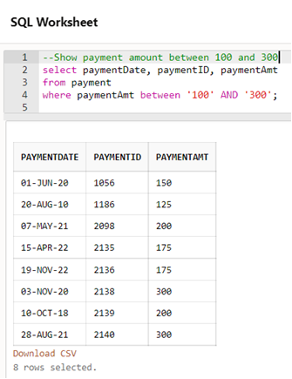

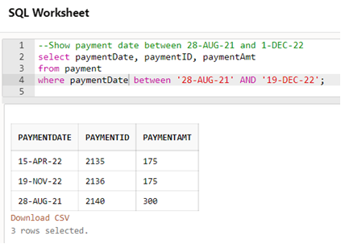

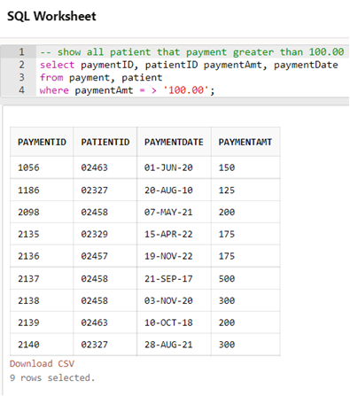

## 

QUERY 1: Show the BillingID and Billing Date where Billing Amont is between 200 and 300.

SELECT BillingDate, BillID, BillingAmt

FROM Billing

WHERE BillingAmt BETWEEN ‘200’ AND ‘300’;

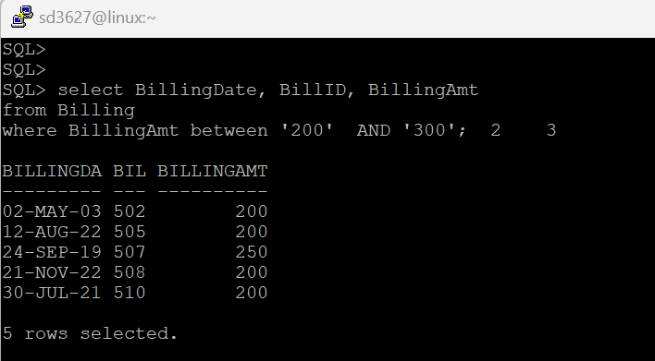

QUERY 2: Find the total Billing Amount of the patient with name ‘Harsh Ramesh’

SELECT SUM(B.BillingAmt)

FROM Billing B, Treatment T, Patient P

WHERE B.treatmentID = T.treatmentID

AND T.patientID = P.patientID

AND P.fname = 'Harsh'

AND P.lname = 'Ramesh';

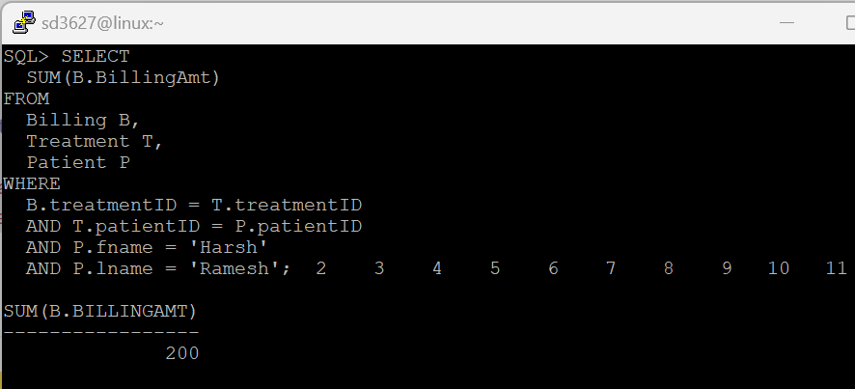

QUERY 3: To find the people who have billing date before 01 January 2015

SELECT b.billingAmt, p.fname, p.lname

FROM patient p, treatment t, billing b

WHERE p.patientID = t.patientID

AND t.treatmentID = b.treatmentID

AND b.billingDate < '01-JAN-15';

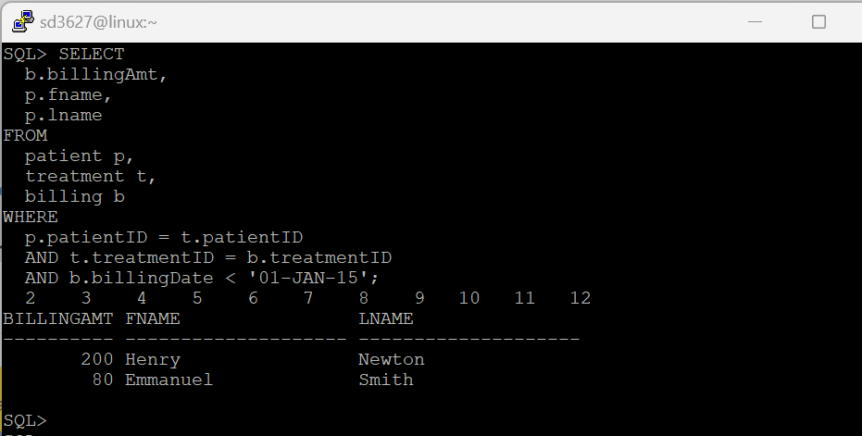

QUERY 1: Show the full name of the manager of each branch.

SELECT B.branchID, B.branchName, M.managerID, S.fname, S.lname

FROM Branch B, Manager M, Staff S

WHERE M.managerID = B.managerID AND M.managerID = S.staffID;

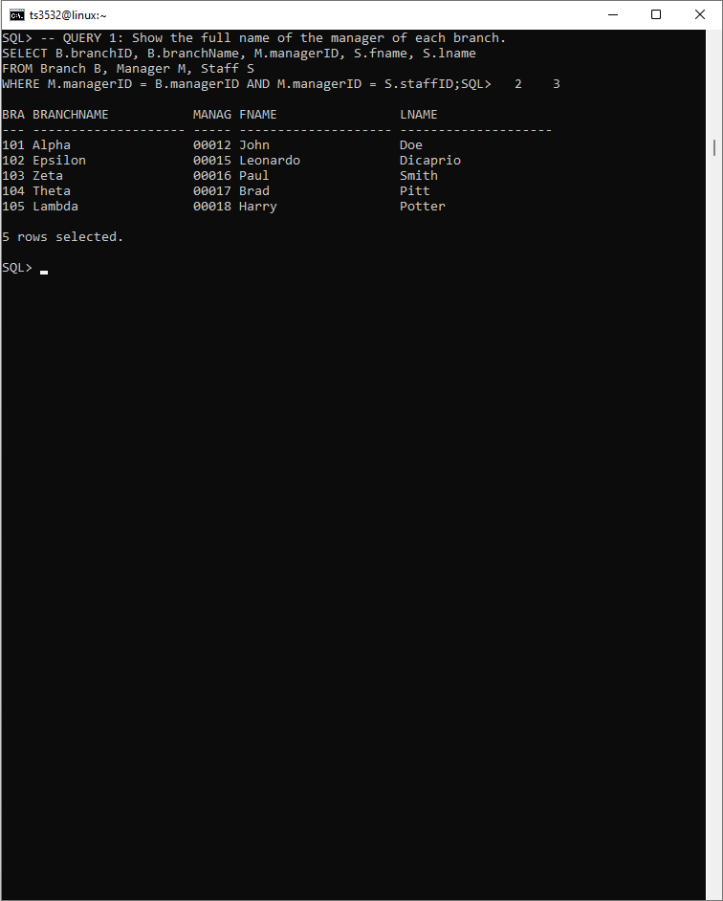

QUERY 2: Find the total number of bills for patient Henry Newton.

SELECT SUM(B.BillingAmt)

FROM Billing B, Treatment T, Patient P

WHERE B.treatmentID = T.treatmentID AND T.patientID = P.patientID AND P.fname = 'Henry' AND P.lname = 'Newton';

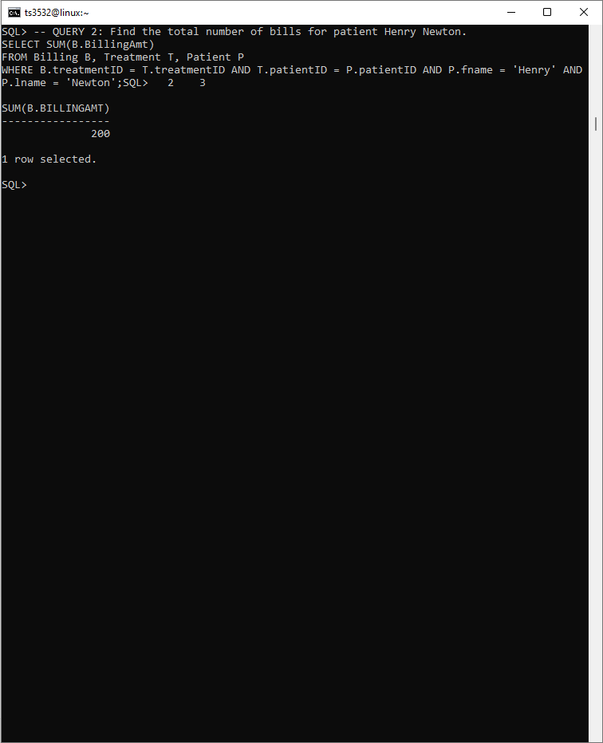

QUERY 3: Show all the departments in which each physician works.

SELECT P.physicianID, P.fname, P.lname, D.deptID, D.deptName

FROM EmploymentRecord E, Department D, Physician P

WHERE P.physicianID = E.physicianID AND D.deptID = E.deptID;

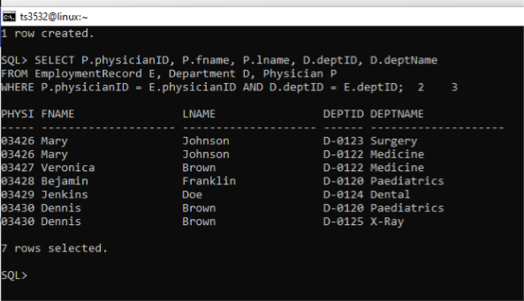

QUERY 1: Display the physicians' first name and last name and the total number of patients that they treat.

SELECT ph.fname, ph.lname, COUNT(pt.patientID)

FROM physician ph, treatment t, patient pt

WHERE ph.physicianID = t.physicianID

AND pt.patientID = t.patientID

GROUP BY ph.lname, ph.fname;

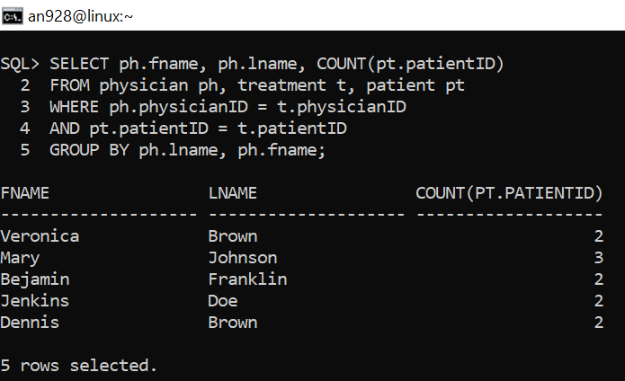

QUERY 2: Display the number of patients who received treatment before 01-JAN- 2022.

SELECT COUNT(pt.patientID)

FROM patient pt, treatment t

WHERE pt.patientID = t.patientID

AND treatmentDate < '01-JAN-2022';

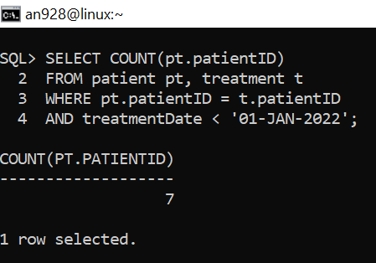

--QUERY 3: Display the number of patients treated by each specialty, order by specialty.

SELECT ph.specialty, COUNT(pt.patientID)

FROM physician ph, treatment t, patient pt

WHERE ph.physicianID = t.physicianID

AND pt.patientID = t.patientID

GROUP BY ph.specialty

ORDER BY ph.specialty;

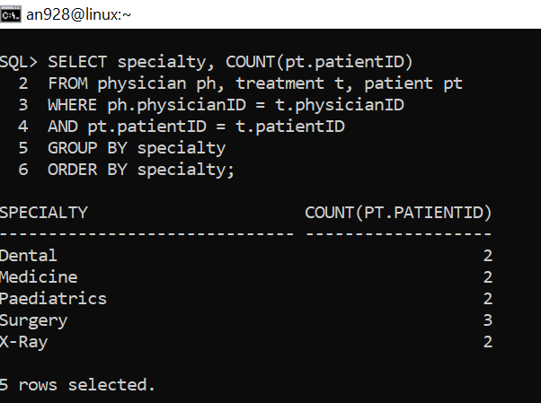

## 

QUERY 1: Display name and the billing amount of all the patients that have 'X-ray' on their treatment's record.

SELECT b.billingAmt, p.fname, p.lname

FROM patient p, treatment t, billing b

WHERE p.patientID = t.patientID

AND t.treatmentID = b.treatmentID

AND treatmentDesc = 'X-ray';

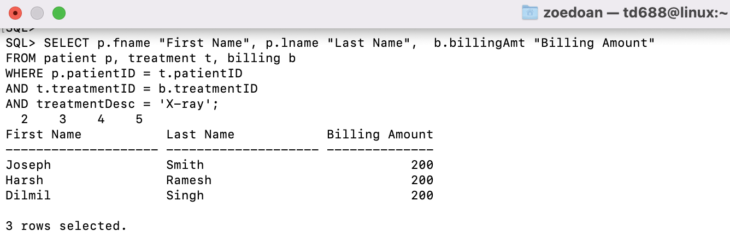

QUERY 2: Display patient IDs and appointment time of patients who have last name begin with letter 'S'. Order the results in descending order of patient ID.

p.patientID, a.apptTime “Date and Time”

FROM patient p, appointment a

WHERE a.patientID = p.patientID

AND p.lname like 'S%'

ORDER BY p.patientID DESC;  
  
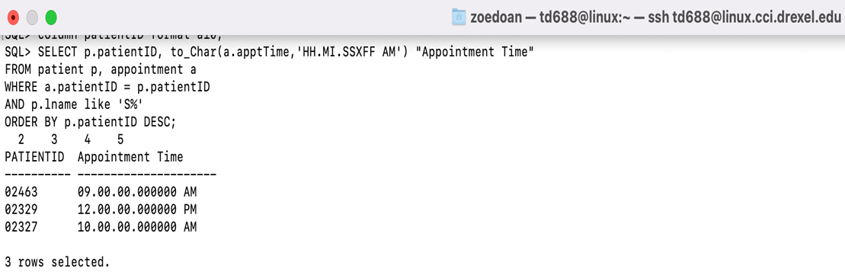

QUERY 3: Display the statistics for patient with ID '02458'. The statistics include the largest payment amount that patient had paid,the smallest payment amount that patient had paid, the total payment amount of all payment,

SELECT max(paymentAmt) "The largest payment amount", min(paymentAmt) "The smallest payment amount", sum(paymentAmt) " Total payment amount"

FROM payment

WHERE patientID = '02458';

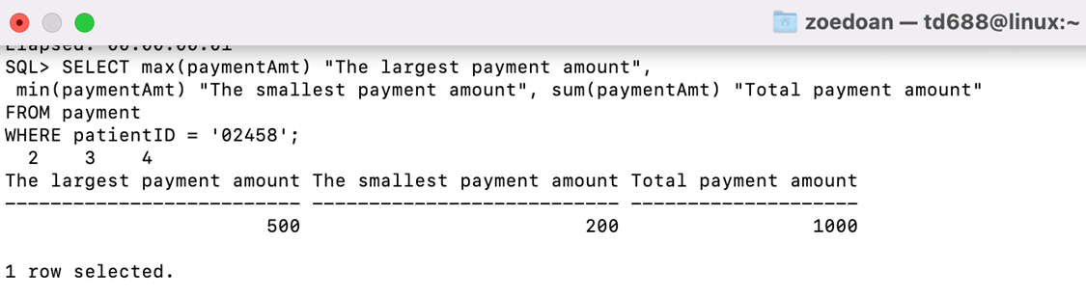

# DATA MANIPULATION

UPDATE EmploymentRecord

SET deptID = 'D-0122'

WHERE physicianID = '03428';

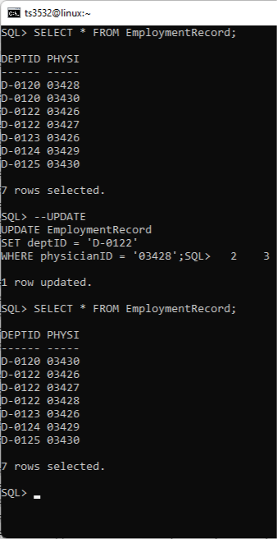

DELETE FROM Appointment

WHERE apptDate = '25-DEC-22';

Before:

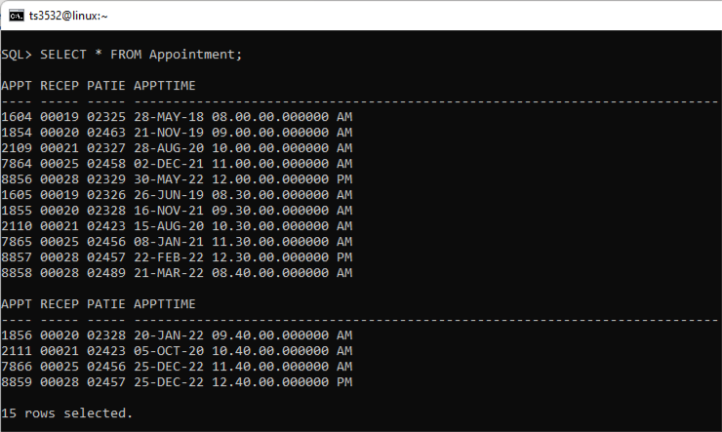

After:

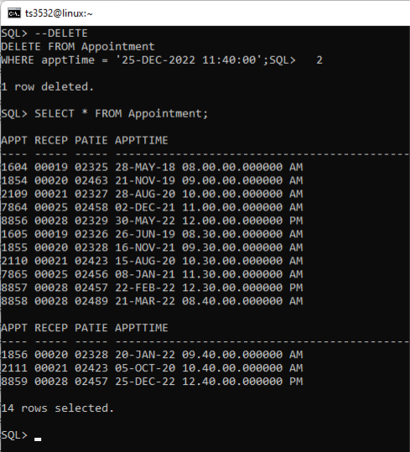

UPDATE physician

SET specialty = 'Cardiovascular'

WHERE specialty = 'Surgery';

Before:

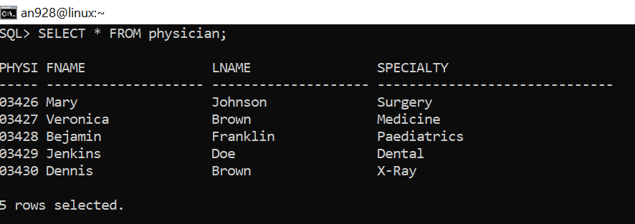

After:

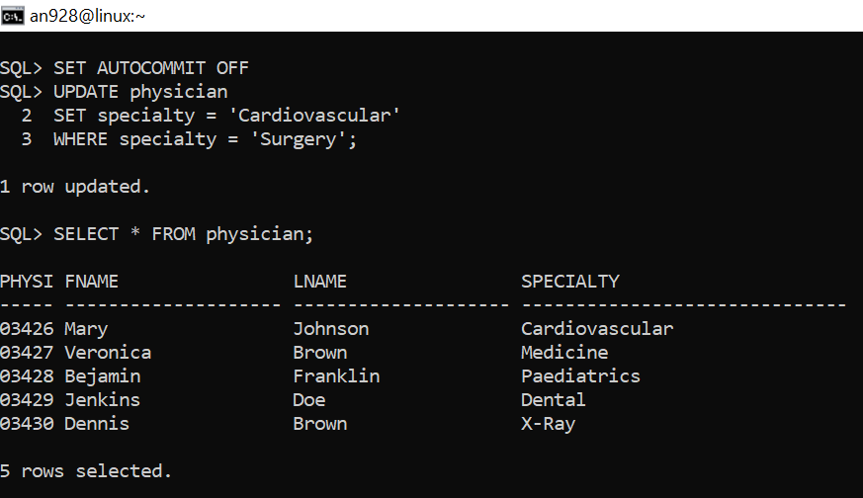

DELETE FROM treatment

WHERE treatmentdesc = 'Knee replacement';

Before:

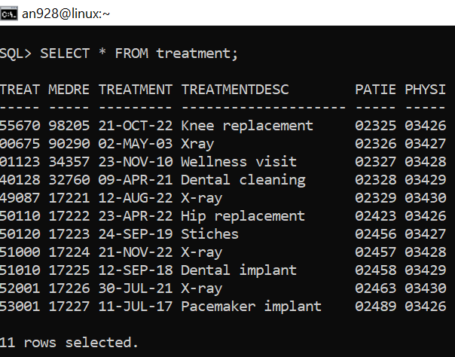

After:

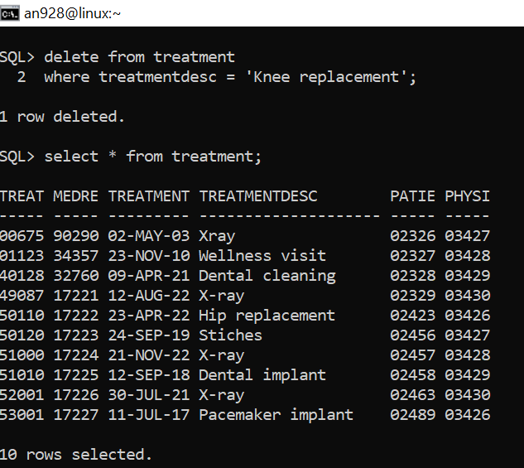

## 

UPDATE patient

SET fname = 'Zoe'

WHERE fname = 'John';

Before update:

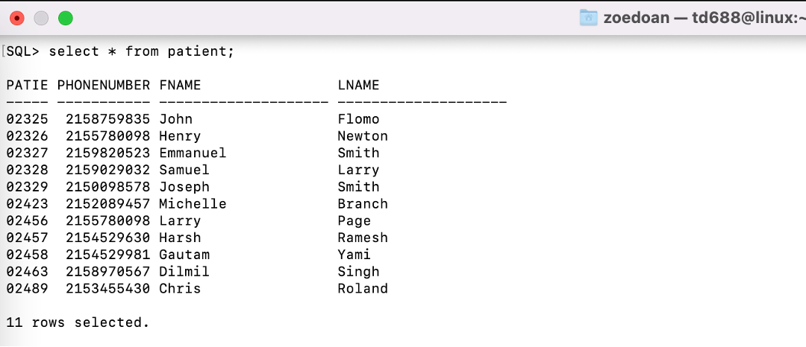

After update:

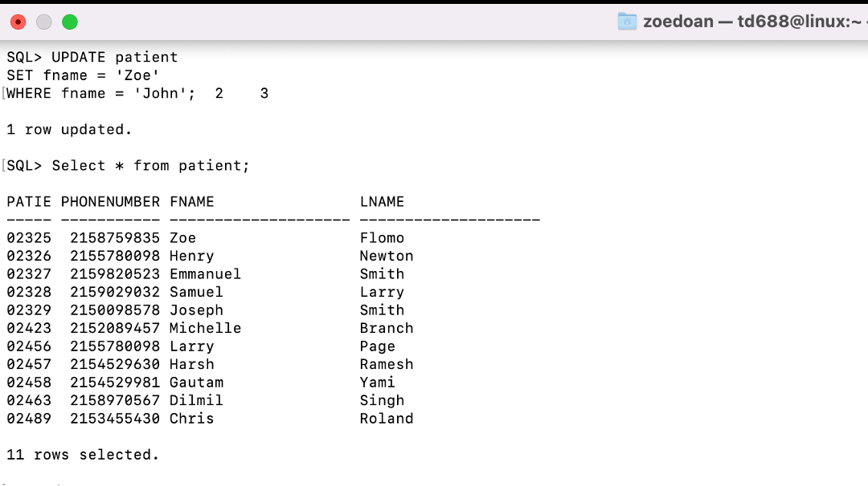

DELETE FROM payment

WHERE patientID = '02458';

Before delete:

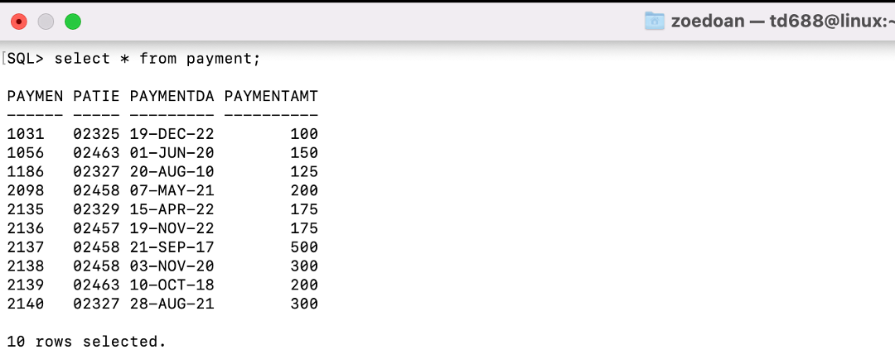

After delete:

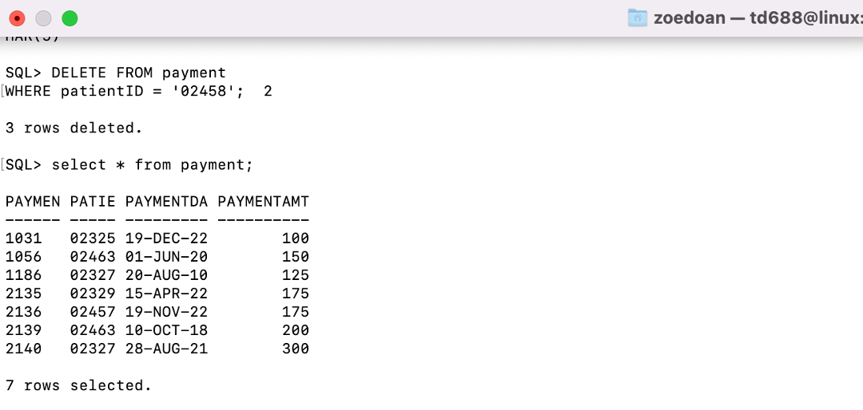

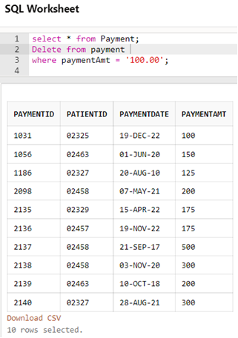

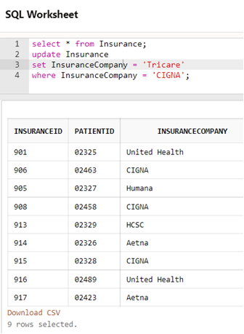

UPDATE: UPDATE Staff

SET fname = 'Siddharth'

WHERE fname = 'Leonardo';

Before UPDATE:

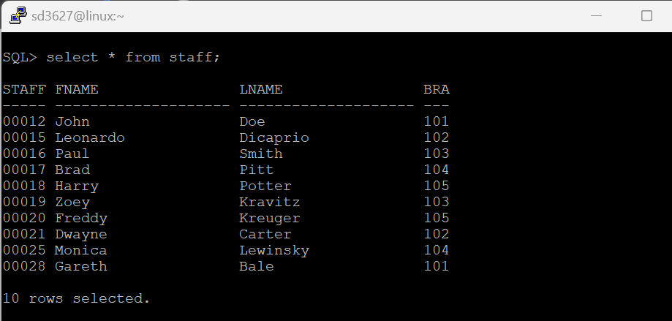

After UPDATE:

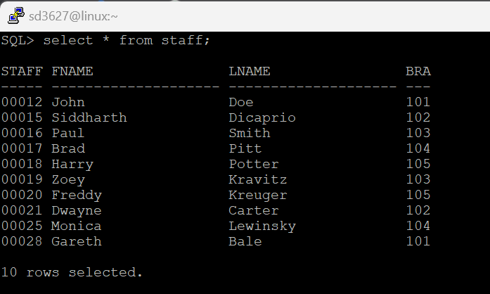

DELETE: DELETE FROM Billing

WHERE BillID = '511';

Before DELETE:

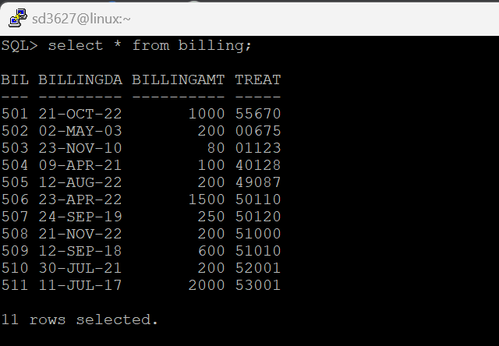

After DELETE:

